Online Diary – Joshua Baker

18/10/2020

Today was yet another day where I took part in creating a game with a team. This time I was put in with Zakaria Ahmed, Jessica Evans and Yap Hou Yuen (Steve). The premise of the game that we were tasked to create was one created from the foundation of noughts and crosses with a mechanic that would randomise the game. As a team we modified the game to include a random event ranging from wiping the entire board to adding extra rows or columns to the board. We made the game best of 3 or 5 due to the average length of each game and we wanted to change the rules of the original noughts and crosses as little as possible to make the game as simple as possible.

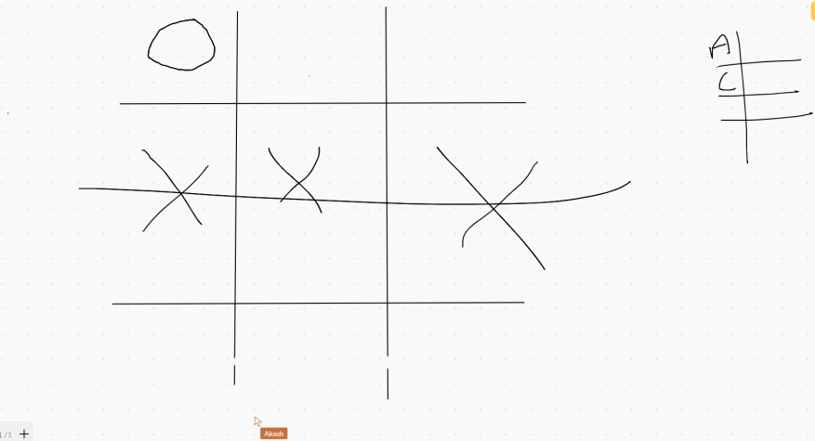The game is played through 2 players and a coin flip decides who goes first (or agreed upon by both players). The board starts of by a 2 by 2 square board. Player 1 is X and player 2 is O, they both take turns placing their marks on empty squares. The first player to get 3 of their marks in a row (horizontal, vertical or diagonal) is the winner. When all squares are full, the game is a tie and the game is played again.

We used a website to play the game which is basically an online whiteboard, we decided to stay with tradition and let the players draw their board and score board just as you would on some piece of paper.

<https://awwapp.com/b/ubuyyuvatj5yd/#> (this is the website)

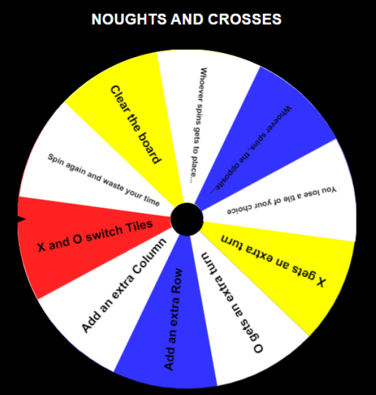The chance mechanic that we implemented is a wheel that contains random events/conditions that applies to either player 1, player 2 or both players. Here is a list of the random events that was on the wheel:

* Add an extra Row
* Add an extra Column
* X and O switch Tiles
* Spin again and waste your time
* Clear the board
* X gets to place a --- on the board
* gets to place a --- on the board
* X loses a tile of their choice
* loses a tile of their choice

The wheel could only be spun after both players have placed their mark on the board. We also used a website for the wheel: <https://wheeldecide.com/index.php?c1=X+gets+an+extra+turn&c2=O+gets+an+extra+turn&c3=Add+an+extra+Row&c4=Add+an+extra+Column&c5=X+and+O+switch+Tiles&c6=Spin+again+and+waste+your+time&c7=Clear+the+board&c8=Whoever+spins+gets+to+place+a+---+on+the+board&c9=Whoever+spins%2C+the+opposite+person+can+place+a+---+on+the+board&c10=You+lose+a+tile+of+your+choice&t=Noughts+and+Crosses&time=5>

After some external play testing, the team found out that the rules: X gets an extra turn and 0 gets an extra turn was too unbalanced. As a team we all agreed upon the solution to remove these rules because they were too unfair. This was because the game would instantly end after one of these landed. We also found that games were too quick which lead to the creation of our best of 3 or 5 rule to let the player have more fun when playing the game.

My experience with my team this week was very healthy and productive, I felt that more often than not everyone was on the same page and we came to conclusions very quickly, because of that fact we were able to get some external play testing done which was extremely beneficial to the game. I felt like we did a lot of things right however I still feel like presentation is a key problem and has been many times over the past month, this is definitely something I have to work on to improve my work.